

KR-MON03
Kraken Ultra Bright 7" 4K Underwater Monitor

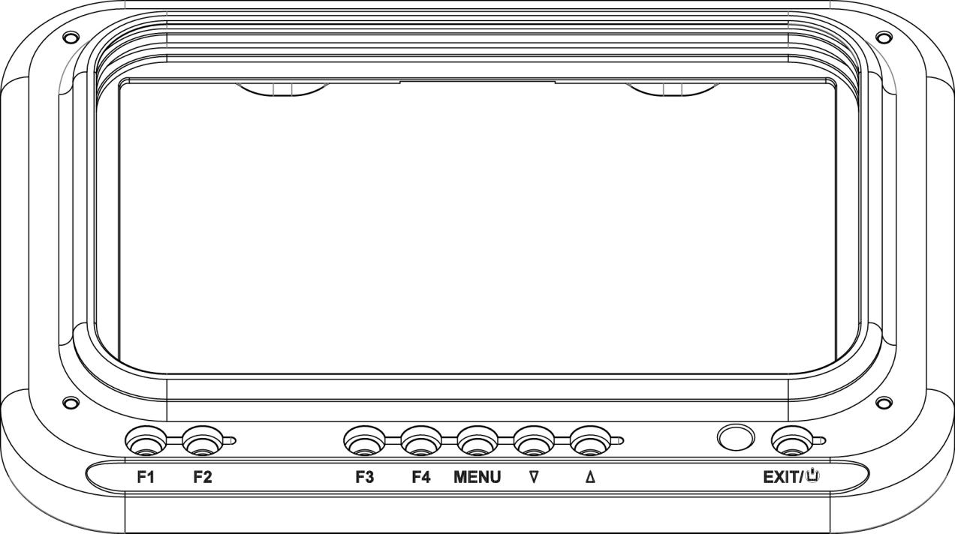
User Manual

Product Overview

Thank you for purchasing the Kraken Ultra Bright 7" 4K Underwater Monitor. This monitor is a professional grade IPS LED panel, boasting extremely high brightness, low power consumption, and stable performance. Equipped with HDMI input, the monitor is ideal as a portable, lightweight viewfinder and video monitor, but suitable for a variety of different applications.
Advanced features include:

- Histogram
- False colours
- Zebra exposure
- Focus assist
- Nine grid
- Embedded audio
- Center marker
- Safe frames
- Colour temperature
- Picture settings
- Colour settings


CAUTION
To ensure proper function of the monitor, please read the user’s manual carefully.
- Discontinue use immediately should you notice any water leaking from the monitor.
- Discontinue use immediately should you notice any cracks on the LCD screen.
- Do not open the battery cap or the bulkhead cap in a wet or sandy environment.
- Avoid dropping the monitor.
- The LCD screen of this product is made of glass. Protect the screen from falls, or coming into contact with hard objects.
- Keep the monitor away from heat sources, such as radiator, water heaters, stoves, etc.
- Avoid prolonged exposures to the sun, as the LCD screen could be damaged.
- The charger included is a USB C PD, standard USB C chargers will not charge the battery. It is recommended to use only the battery and charger included.
- Always turn off the monitor before removing the battery.
- To avoid damaging the product, please do not take apart or repair the unit by yourself.
- For optimal maintenance, and to avoid scratching the screen, gently wipe the screen using a clean, soft fibred cloth. Do not use chemical solutions to clean the screen.
General Features
- Waterproof 80m/266ft
- 2200nit Brightness
- IPS 4K LCD panel
- 4K HDMI signal input
- 3840×2160p (30/29.97/25/24/23.98 Hz) / 4096×2160p (24Hz)
- Burn Time:140 minutes @100% brightness
- Analog stereo L/R, embedded audio display
- Histogram
- Focus assist - focus edge can be red, green, or blue
- Zebra exposure and false colour function
- Check field - red, green, blue, mono
- Anamorphic mode

Image Features
- Flip (H, V, H/V)
- Image Freeze
- Nine grid - zoom one of the images to full screen
- Image Zoom-in function
- Pixel to pixel
- Marker types, safe frames and center marker
- Display and adjust the image colour temperature
- Brightness, contrast, tint, saturation and colour temperature adjustment

Package Contents

1. Monitor (Including HDMI-IN Bulkhead)
2. 21700 Battery x 2
3. USB-C PD charger (AC adapter)
4. USB-C PD cable (for charging the battery)
Note: always must use a USB C PD cable, standard USB C will not charge the device
5. HDMI cable (60cm)
6. HDMI bulkhead with M16 thread with soft cable
7. M16-M24 thread adapter for HDMI bulkhead
8. Micro HDMI plug
9. Mini HDMI plug
10. Standard HDMI plug
11. Ball mount
12. Spare O-ring for battery cap (O ring ID49 x CS2.0)
13. Spare O-ring for bulkhead (O ring ID26 x CS1.5)
14. Spare O-ring for M16-M24 thread adapter (O ring ID20 x CS2.0)

Product Description
- Front Panel/ Button Instruction

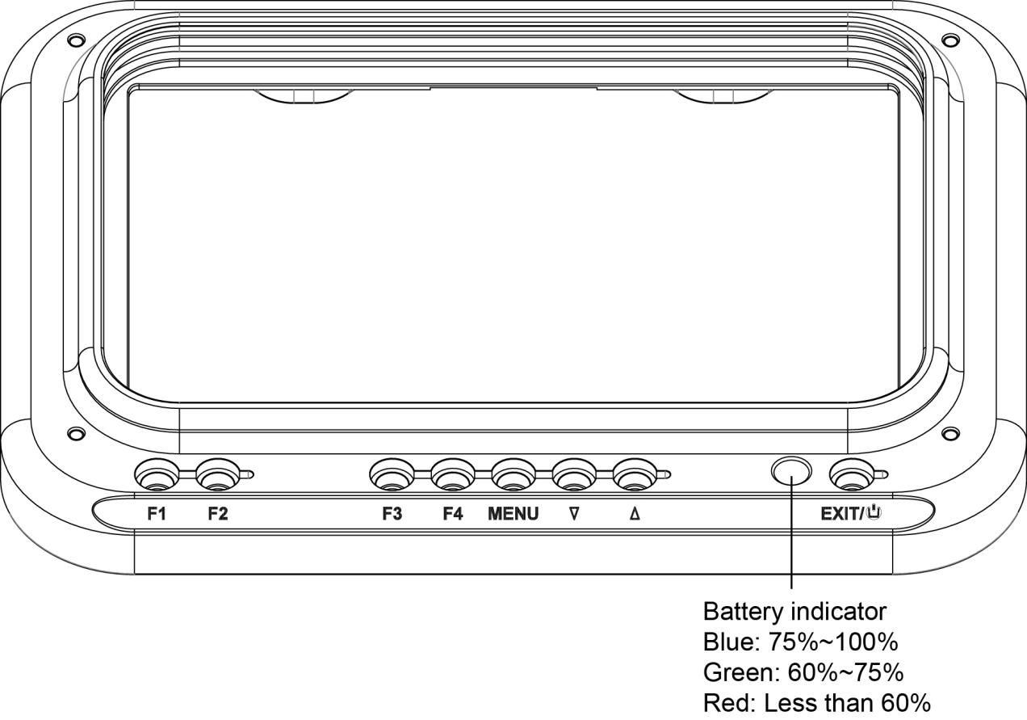

Button | Function when OSD is not displayed | Function when OSD is  displayed
F1 | Custom button F1 | N/A
F2 | Custom button F2 | N/A
F3 | Custom button F3 | N/A
F4 | Custom button F4 | N/A
MENU | Display OSD main menu | Confirmed Select
∨ | Reduce the backlight brightness | Select next menu item
∧ | Increase the backlight brightness | Select previous menu item
EXIT/POWER | Power on/off button | Return to previous OSD m

- Rear Panel Instruction

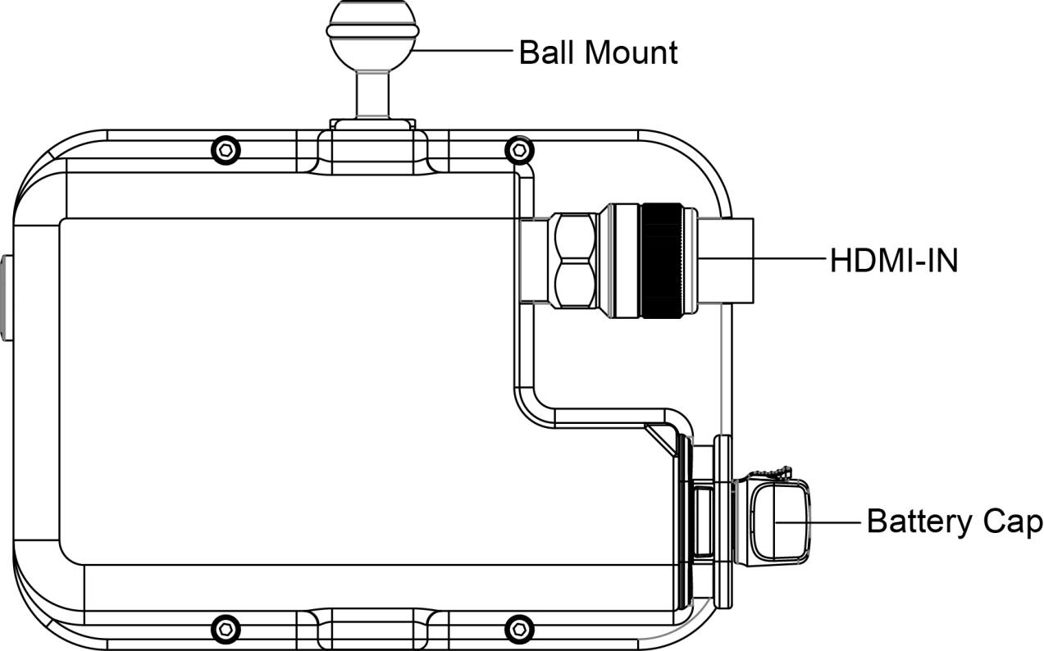

- Battery / Charger
1. Only used the battery provided by the manufacturer.
2. Do not open the battery cap when the monitor is in the water.
3. If the monitor will not be used for a long period of time, the batteries should be removed.
4. To charge the battery, use the USB-C PD charger included with your monitor.
5. When the battery begins to charge, the indicator light on the battery will be RED.
6. When the battery is fully charged, the indicator light on the battery will change to BLUE.

Operating Your Monitor

- After correctly installing the battery, press and hold the "POWER" button for one second. The indicator ring will be blue or red and the monitor will turn on.
- When the menu is not displayed,pressing the ∨or ∧ button will allow adjustment of the backlight.
- Press the MENU button to access the main menu. Use the ∨or ∧buttons to scroll through the menu categories across the top. Once you have selected the desired menu category, use the ∨or ∧ buttons to scroll through the list of items within that category. Press the EXIT/POWER button again to return to the previous OSD menu, or waiting a few seconds time to exit the menu auto.



Shortcut Key

The Four shortcut key buttons F1,F2,F3 and F4 can be programmed with a feature of your preference. To set each button, select the menu category, then press the ∧ button to select “User option”, then select “ Shortcut Key”, after then press the ∨or ∧ buttons to scroll through the feature options, and press the MENU button to confirm your selection and program the shortcut button.

Options: safe frames, check field, focus assist, aspect ratio, image flip, image freeze, histogram, false colours, over exposure, embedded audio, nine grid, zoom, anamorphic, center marker

Menu Categories and Options

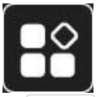

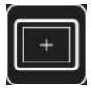

Assistant
Menu Items | Options
All Waves | Off, On
Waveform | Off, On,Mode,Waves Trans
Vector | Off, On
Histogram | Off, On,Mode
Focus Assist | Off, On,Color,Peaking Level
Embedded Audio | Off, On
Zebra Pattern | Off,On,Threshold Value
Check Field | Off, On,Mode
False Colors | Off, On,Mode

Marker
Menu Items | Options
Grids | Off, On,Mode,Rows,Columns,Color
Safe Frames | Off, 80%, 85%, 90%, 93%, 96%, 2.35:1,9:16
Center Marker | Off, On,Color
Ratio Marker | Off, 4:3, 13:9, 14:9, 15:9, 16:9, 1.85:1, 2.35:1,9:16,1:1
Mark Colour | Red, Green, Blue, Black, White,Gray
Modified Mark | 0~5



Image
Menu Items | Options
Scan Mode | Under Scan,Over Scan
Aspect Ratio | Auto,16:9,16:10,4:3,5:4,1.85:1,2.35:1,Full Scre...
Anamorphic | Off,On,Mode,User
Image Flip | Off, On,Mode
Zoom Mode | Off, On,Mode,User
Image Freeze | Off,On
P2P | Off,On



User option
HDR | Off, On,Mode
Display Adjustment | Backlight,Brightness,Contrast,Saturation,Tint
Color Adjustment | Display Range,Color Temp,Red,Green,Blue
Shortcut Key | F1 All Waves,F2 Center Marker,F3 Safe Frames,F4 False Colors
Left Right Key Set | Volume Backlight



System
User Switch | 1,2,3,4
Languages | English, 简体中文, Español, Português, Français, Nederlands, Deutsch, 日本語, 繁體中文, 한국以로, руссKий языK
OSD Option | OSD Time: Off, 15 seconds, 30 seconds, 45 seconds OSD Trans: Off,25%,50%,75% No Signal: Red Green,Blue,Black,White,Gray
EDD Settings | 2.0,1.4
Volume | Off, On,0~100
Power Setting | Auto,Manual
Reset | Confirm

Technical Parameters

Panel Size | 7" IPS
Resolution | 1920x1200 pixels
Dot Pitch | 0.07875(W) x 0.07875 (H)mm
Aspect Ratio | 16:10
Brightness | 2200cd/m2
Contrast | 1200: 1
Viewing Angle | 80°/80°(L/R) 80°/80°(U/D)
Backlight | LED
Input | HDMI
HDMI Input | 480i/576i/480p/576p  720p(60/59.94/50/30/29/25/24/23.98)  1080i(60/59.94/50)  1080p(60/59.94/50/30/29.97/25/24/24sF/23.98/23.98sF)  4K UHD 3840×2160p (30/29.97/25/24/23.98 Hz) 4096×2160p (24Hz)
Power Consumption | ≦18W
Unit Size | 220Lx147Hx90D (mm)
Unit Weight | 2214g on land/560g underwater (With battery)
Mount Points | 1/4"-20 Thread Point (For mounting ball )
Working Temperature | -20℃~55℃
Storage Temperature | -30℃~65℃
Depth Rating | 80 meters/266ft

Installing the battery

Step 1: Push out the red safety lock,at the same time rorate the battery knob as counter-clockwise,then take the battery cover out.

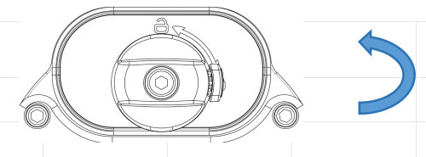

Step 2: Put the batteries as below shown (Correct direction/positive and negative anodes) to the body,press the battery cover at the same time rorate the battery knob as clockwise.
Noted:Make sure that the safety lock has returned to the locked position.(It is securely locked when you hear a "click")

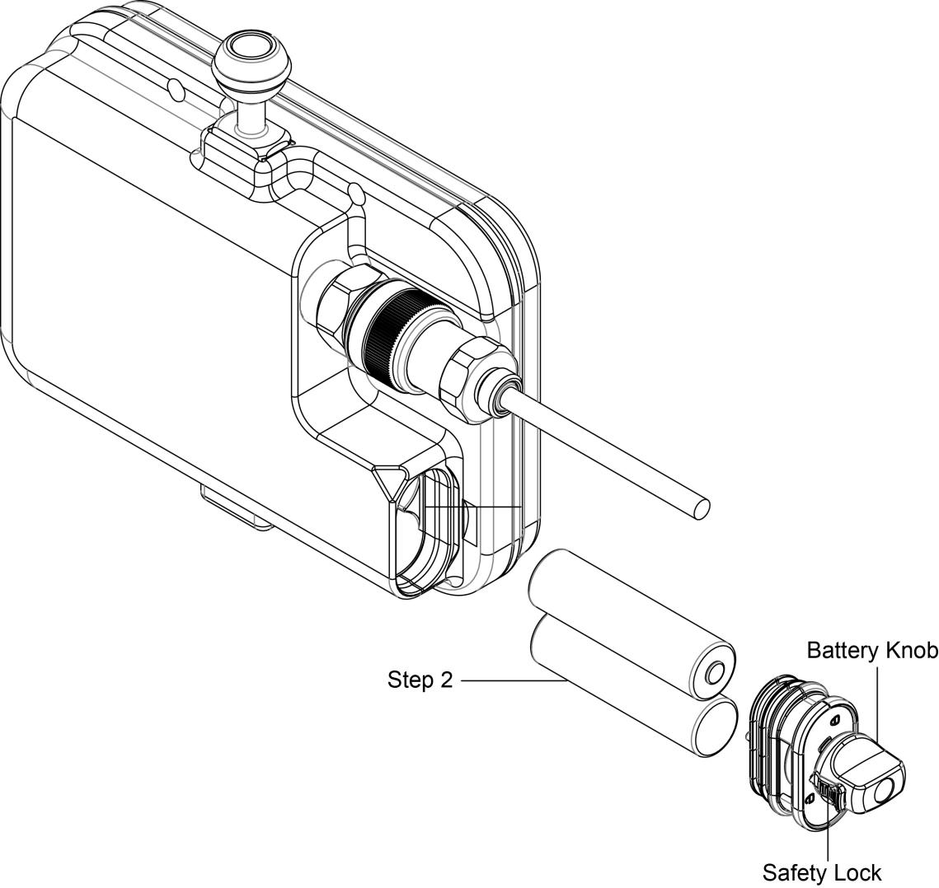

Connecting the HDMI cable to the monitor

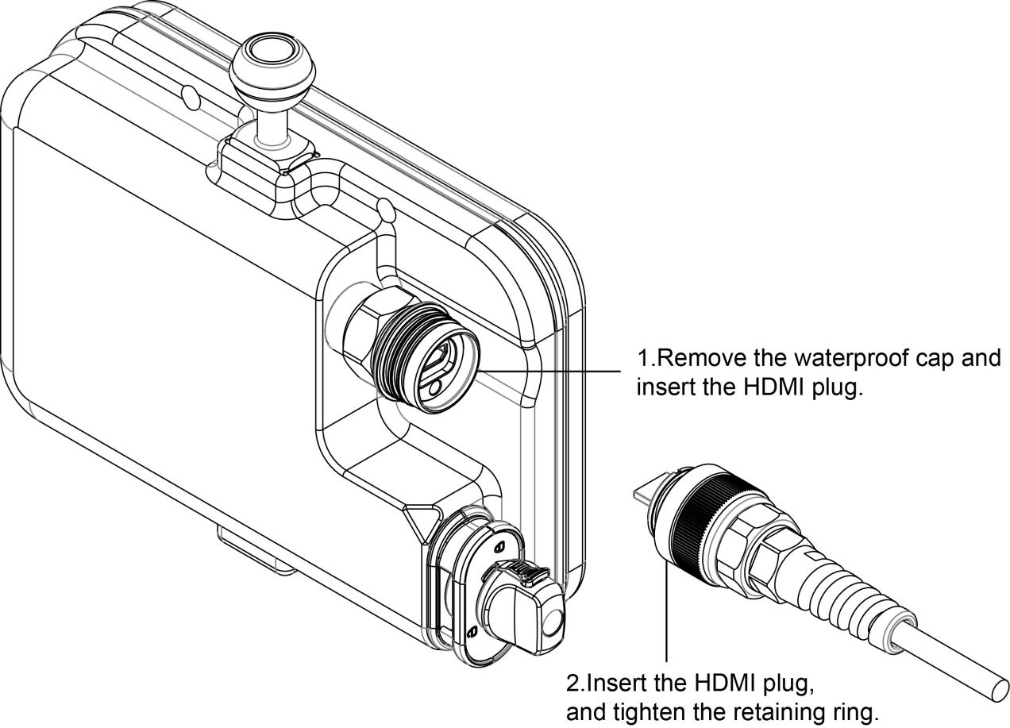

Connect to camera housing

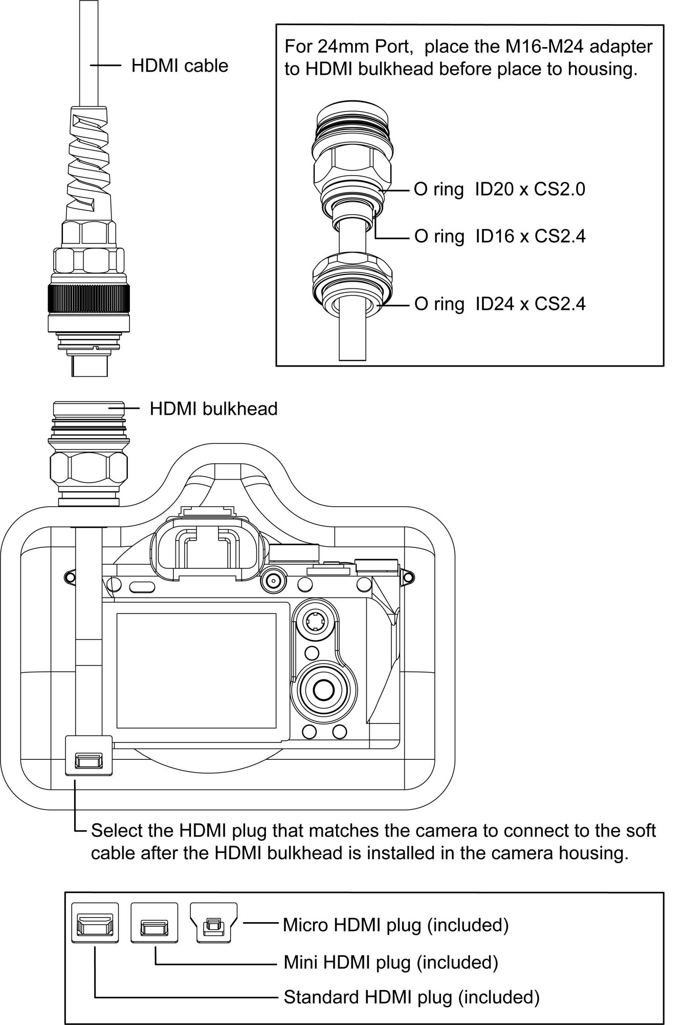

Troubleshooting

Monitor showing only black and white, or monochrome picture.
- Check saturation, brightness & contrast adjustment.
- Check if Check Field in the menu is in black, white or monochrome image or other condition.
There is no image after powering the monitor on.
- Check HDMI cable, cable connections, and if monitor is synchronized with the input signal.
- Check signal cable connection, and make sure to use the standard adapter to connect the monitor. If power is supplied by battery, please check if the battery is fully charged.

As we are constantly striving to improve performance, these specifications are subject to change

