

KR-MON04
5.5" 3000 Nit Ultra Bright Monitor

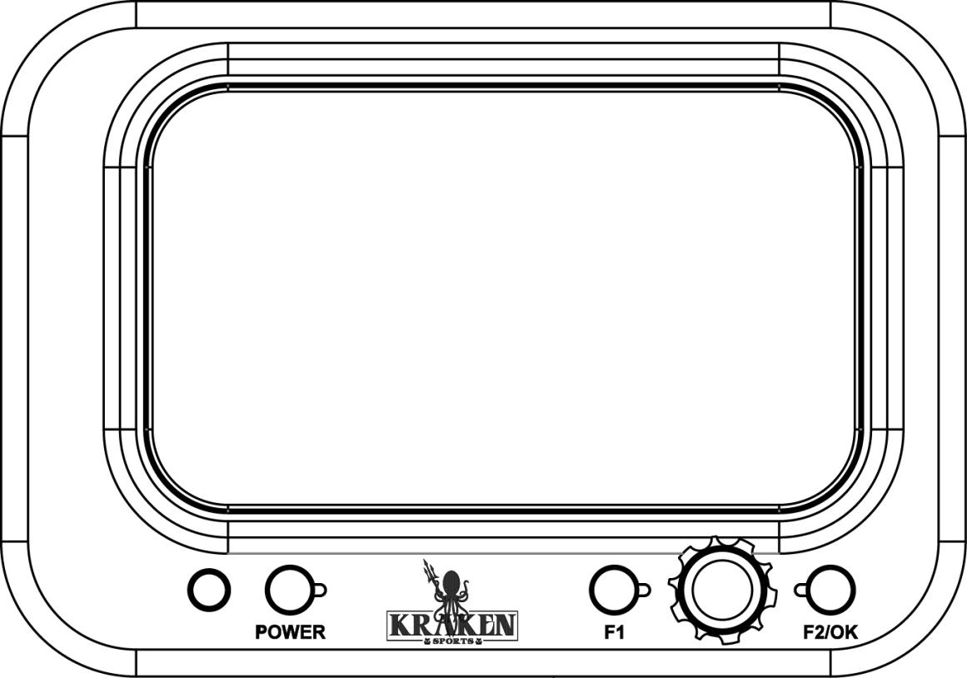

User Manual

Product Overview
Thank you for purchasing the Kraken Ultra Bright 5.5" 4K Underwater Monitor. This monitor is a professional grade IPS LED panel, boasting extremely high brightness, low power consumption, and stable performance. Equipped with HDMI input, the monitor is ideal as a portable, lightweight viewfinder and video monitor, but suitable for a variety of different applications.

FEATURES:

- 1920 x 1080 full HD IPS screen
- Ultra-brightness 3000nit,clearly visible in the sun
- Light sensor auto dimming
- Support HDR monitoring,what you see is what you get
- With Waveform,Vector scope,RGB Histogram,Focus Assist,Monochrome etc,functions


CAUTION
To ensure proper function of the monitor, please read the user’s manual carefully.
- Discontinue use immediately should you notice any water leaking from the monitor.
- Discontinue use immediately should you notice any cracks on the LCD screen.
- Do not open the battery cap or the bulkhead cap in a wet or sandy environment.
- Avoid dropping the monitor.
- The LCD screen of this product is made of glass. Protect the screen from falls, or coming into contact with hard objects.
- Keep the monitor away from heat sources, such as radiator, water heaters, stoves, etc.
- Avoid prolonged exposures to the sun, as the LCD screen could be damaged.
- The charger included is a USB C PD, standard USB C chargers will not charge the battery. It is recommended to use only the battery and charger included.
- Always turn off the monitor before removing the battery.
- To avoid damaging the product, please do not take apart or repair the unit by yourself.
- For optimal maintenance, and to avoid scratching the screen, gently wipe the screen using a clean, soft fibred cloth. Do not use chemical solutions to clean the screen.
General Features
- Waterproof 80m/266ft
- 3000nit Brightness
- IPS 4K LCD panel
- 4K HDMI signal input
- 3840×2160p (30/29.97/25/24/23.98 Hz) / 4096×2160p (24Hz)
- Burn time:More than 150 minutes @ 100% brightness
- Analog stereo L/R, embedded audio display
- Histogram
- Focus assist - focus edge can be red, green, or blue
- Zebra exposure and false colour function
- Check field - red, green, blue, mono
- Anamorphic mode

Image Features
- Flip (H, V, H/V)
- Image Freeze
- Nine grid - zoom one of the images to full screen
- Image Zoom-in function
- Pixel to pixel
- Marker types, safe frames and center marker
- Display and adjust the image colour temperature
- Brightness, contrast, tint, saturation and colour temperature adjustment

Package Contents

1. Monitor (Including HDMI-IN bulkheads)
2. Battery: 2 x 21700 battery with type C charging port
3. USB-C PD charger (AC adapter)
4. USB-C PD cable (for charging the battery)
Note: always must use a USB C PD cable, standard USB C will not charge the device
5. HDMI cable (60cm)
6. HDMI bulkhead with M16 thread with soft cable
7. M16-M24 thread adapter for HDMI bulkhead
8. Micro HDMI plug
9. Mini HDMI plug
10. Standard HDMI plug
11. Ball mount
12. Spare O-ring for battery cap (O ring ID49 x CS2.0)
13. Spare O-ring for bulkhead (O ring ID26 x CS1.5)
14. Spare O-ring for M16-M24 thread adapter (O ring ID20 x CS2.0)

Product Description
- Front Panel/ Button Instruction

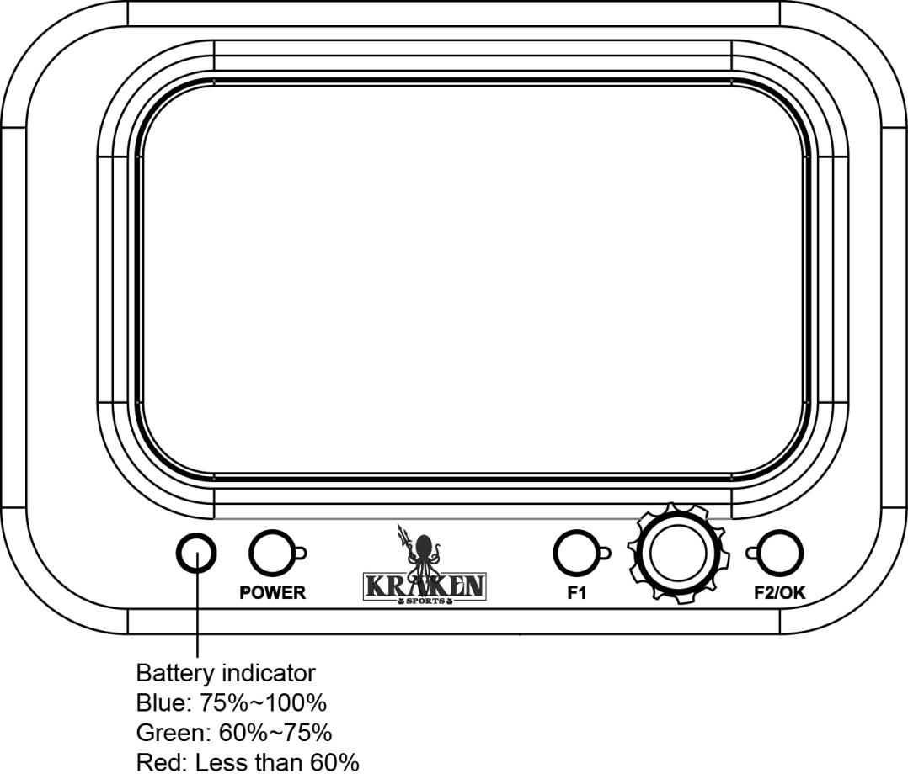

Button | Function when OSD is not displayed | Function when OSD is  displayed
F1 | Custom button F1 | N/A
F2/OK | Custom button F2 | N/A
Knob | Changed the functions
POWER | Power on/off button

- Rear Panel Instruction
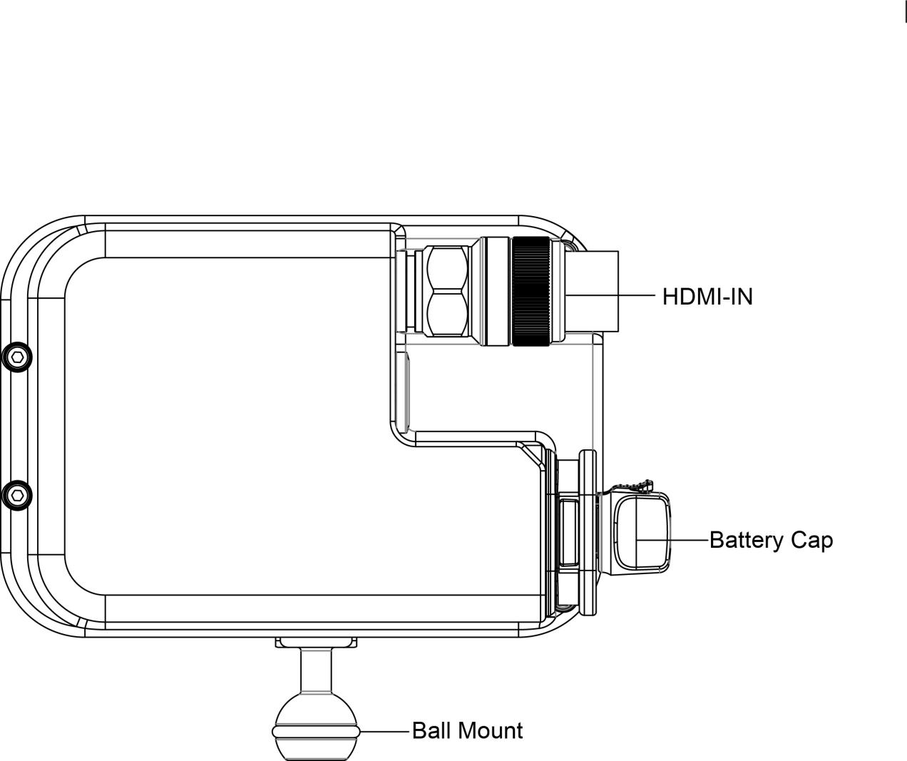

- Battery / Charger
1. Only used the battery provided by the manufacturer.
2. Do not open the battery cap when the monitor is in the water.
3. If the monitor will not be used for a long period of time, the battery should be removed.
4. To charge the battery, use the USB-C PD charger included with your monitor.
5. When the battery begins to charge, the indicator light on the battery will be RED.
6. When the battery is fully charged, the indicator light on the battery will change to BLUE.

Operating Your Monitor

- After correctly installing the battery, press and hold the "POWER" button for one second. The indicator ring will be blue or red and the monitor will turn on.
- When the menu is not displayed, pressing the < Button F1/Button F2 will show the Focus Assist,Y Histogram,Audio Meter,RGB Parade,Vector,All Waves.
- Knob: Changed the functions by knob.
- F1: Short press will be back to previous step.

Menu Function Instruction
All Waves | OFF,ON  After turning on,waveform,vector,histogram and embedded audio will be shown.
Parade | OFF,RGB,YUV,Y  This essential feature assists with the calibration of professional video cameras.It shows the overall brightness of the image assisting the video professional in correcting exposure. The waveform feature also checks the evenness of the lighting when lighting a chromakey or background.
Vector | OFF,ON  Shows how saturated the image is and where the pixels in the image land on the color spectrum.
Histogram | OFF,ON
Focus Assist | OFF,ON  After the Focus Assist is turned on,the Focus Level （1~10）and Focus Color (yellow,red,green,blue,white) can be adjusted.
Audio Meter | OFF,ON
Zebra | OFF,ON  After the Zebra is turned on,the Zebra Value (1%~100%) can be adjusted.
Monochrome | OFF,gray,red,green,blue
False Color | OFF,type1,type 2
Return | Back to the previous OSD menu


Nine Grid | OFF,ON
SafetyMarker | OFF,70%,80%,90%,16:9, 16:10, 4:3, 5:4, 1:1,  1.91:1.1, 4:5, 9:16, 1.85:1, 2.35:1
Center Marker | OFF,ON
Marker Mat | OFF,16:9, 16:10, 4:3, 1.85:1, 2.35:1, 2.41:1, 1.9:1, 5:4, 1:1.9  After the Marker Mat is turned on, the Marker Mat Alpha (0%,25%,50%,75%) can be adjusted.
Marker Color | Yellow,red,green,blue,white,black
Return | Back to the previous OSD menu

Scan Mode | Under Scan, Over Scan
Video Aspect | auto, 16:9, 16:10, 4:3,5:4,1.85:1,2.35:1,strectch,user  Under the “user”,you can customize theVideo Width (100%-200%).Video Height (100%-200%).
Anamorphic | OFF,1.25x,1.33x,1.5x,1.6x,1.8x,2.0x,2.0xmag
Auto Mirror | OFF,ON  After turning on,the image will automatically adjust upside down.
Zoom Times | OFF,100%~500%
Freeze | OFF,ON
Pixel to Pixel | OFF,ON
Return | Back to the previous OSD menu
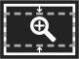

HDR | OFF 、HLG 2020、HLG 709、HLG P3
Lut Switch | Off, On  After the LUT Switch is turned on, you can use the Lut (SLOG2, SLOG3, LOGC, VLOG).
Lut Import (SD) | After copying the 3D Lut file to the SD card and inserting it into the SD card slot,you can click the “<” or “>” key in the Lut (SD) option,or rotate the wheel to import the 3D LUT file. (up to imports 50 LUTs)  Note: the chip should be faced up when inserting the SD card is fully inserted.
Colour Temperature | 5600K, 6500K, 9300K, User  Under “User”, the red, green and blue values of the image can be adjusted.
Backlight  Mode | Auto,manual  When selecting auto mode,the device will adjusting the backlight automatically according to the around environment.
Backlight | 0~100
Brightness | 0~100
Contrast | 0~100
Saturation | 0~100
Hue | 10~100
Sharpness | 0~100
Return | Back to the previous OSD menu
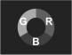

Wheel | Volume, Backlight  After selecting the wheel option,you can click the “ < “or “>” button in the wheel option,or rotate the wheel to select one of the shortcut keys to set in to the rotary wheel adjustment (when the menu is not displayed)
Languages | English, 简体中文, Español, Português, Français, Nederlands, Deutsch, 日本語, 繁體中文, 한국以로, руссKий языK
Transparency | Off, Low, Middle, High
OSD Time | 5s,10s,15s,20s,25s,always
Volume | 0~100
Mute | OFF,ON
Fan Speed | 0~100  When the backlight value is 30-50,the fan speed range is 50%-100%,the backlight value is 50-80,the fan speed range is 70%-100%.
Reset | OFF,ON  After selecting the reset option,you can click the “<” or “>” key in the reset option or rotate the wheel to restore the factory settings.
Firmware Update | After copying the update file to the SD card and inserting it into the SD card slot,you can click the “<” or “>” key in the firmware updated option or rotate the wheel to update.  Note:the chip should be faced up then inserting the SD card,and press it after inserting to ensure that the SD card is fully inserted.
Return | Back to the previous OSD menu



Technical Parameters

Panel Size | 5.5”" IPS
Resolution | 1920x1080 pixels
Dot Pitch | 0.069(L) x 0.069 (W)mm
Aspect Ratio | 16:9
Brightness | 3000cd/m2
Contrast | 1000: 1
Viewing Angle | 80°/80°(L/R) 80°/80°(U/D)
Backlight | LED
Input | HDMI
HDMI Input Support Format | 480i/576i/480p/576p  720p (60/59.94/50/30/29.97/25/24/23.98)  1080i (60/59.94/50)  1080p (60/59.94/50/30/29.97/25/24/23.98)  3840x2160p (30/29.97/25/24/23.98)  4096×2160p (30/29.97/25/24/23.98)
Power Consumption | ≦20W
Unit Size | 142Lx86Hx28D (mm)
Unit Weight | 1680g on land/260g underwater (With battery)
Mount Points | 1/4"-20 Thread Point (For mounting ball )
Working Temperature | -20℃~70℃
Storage Temperature | -30℃~80℃
Depth Rating | 80 meters/266ft

Installing the battery

Step 1: Push out the red safety lock,at the same time rorate the battery knob as counter-clockwise,then take the battery cover out.

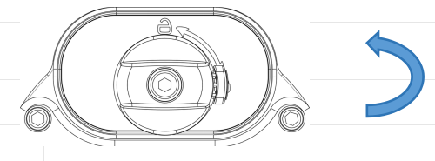

Step 2: Put the batteries as below shown (Correct direction/positive and negative anodes) to the body,press the battery cover at the same time rorate the battery knob as clockwise.
Noted:Make sure that the safety lock has returned to the locked position.(It is securely locked when you hear a "click")
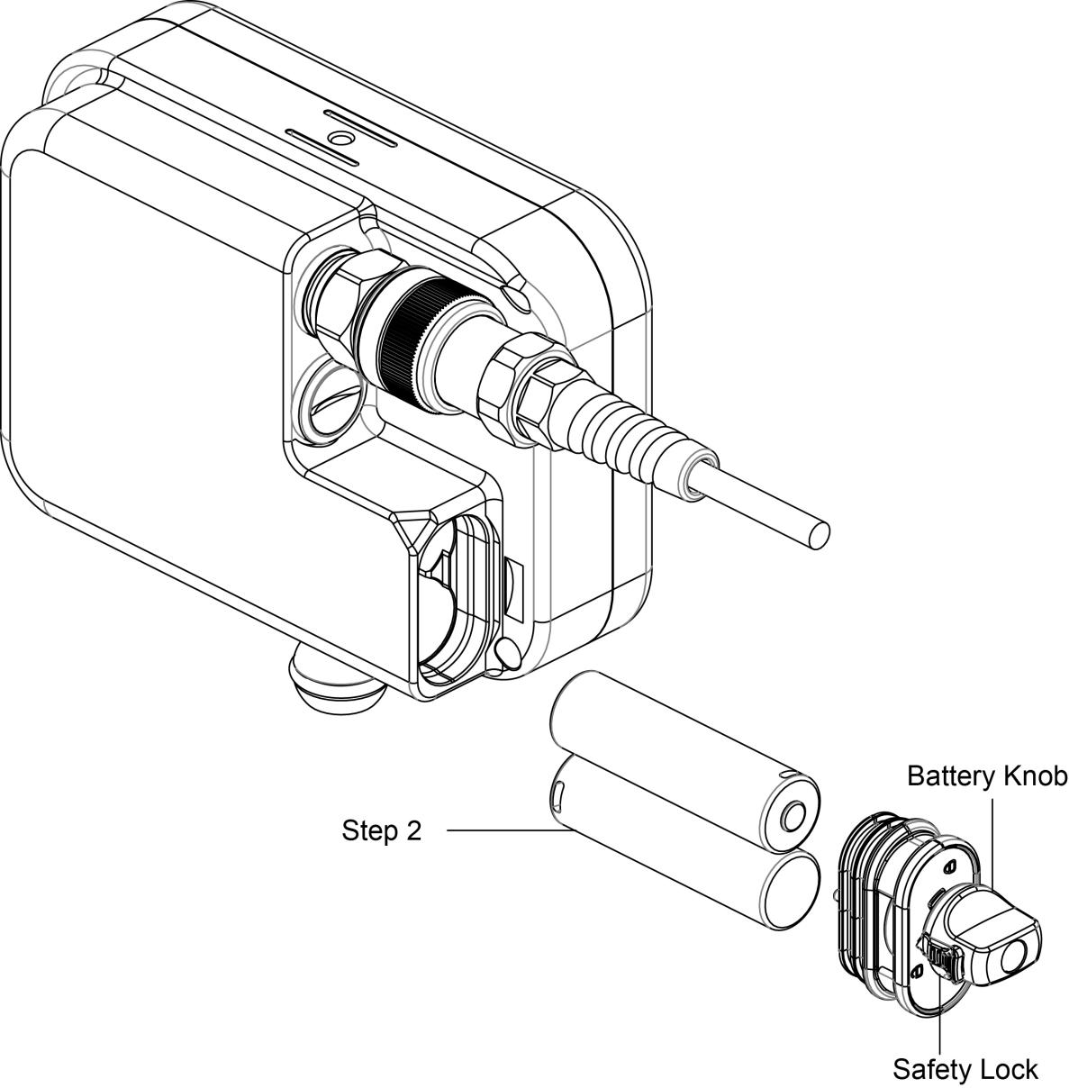
Connecting the HDMI cable to the monitor

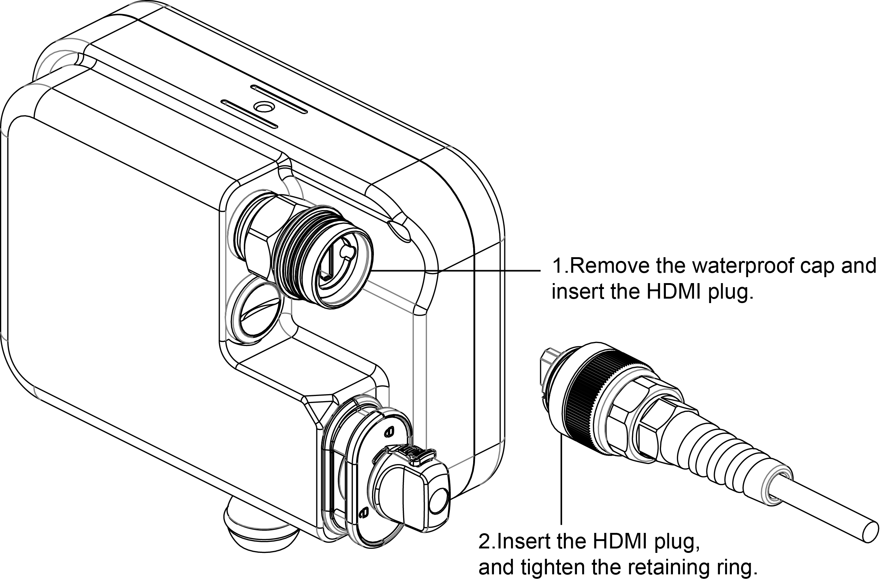

Connect to camera housing

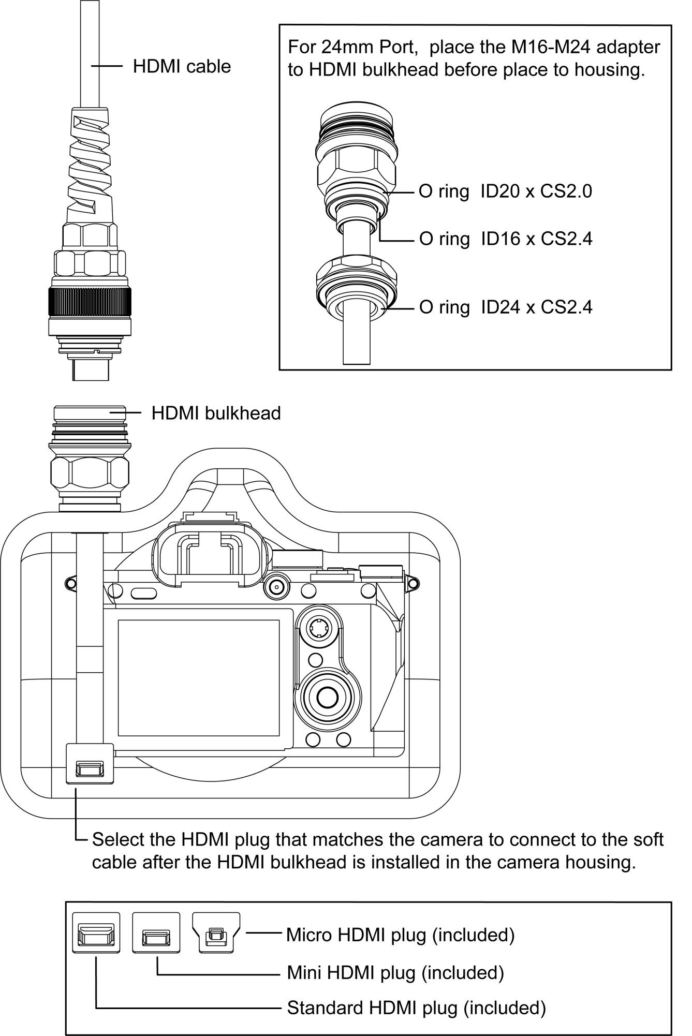

Troubleshooting

Only black and white or monochrome picture.
- Please check saturation, brightness & contrast adjustment.
- Please check “Monochrome” is in black, white or monochrome image or other condition.

No image after put on the power
- Check if HDMI cable connecting is in good condition.
- Check signal cable connecting, and make sure to use the standard adapter to connect the monitor. If power is supplied by battery, please check if the battery is fully charged.

As we are improving product features and product performance,so if there is any change on the specification without prior noti

