KRM 7-2200
Kraken Ultra Bright 7" 4K Underwater Monitor

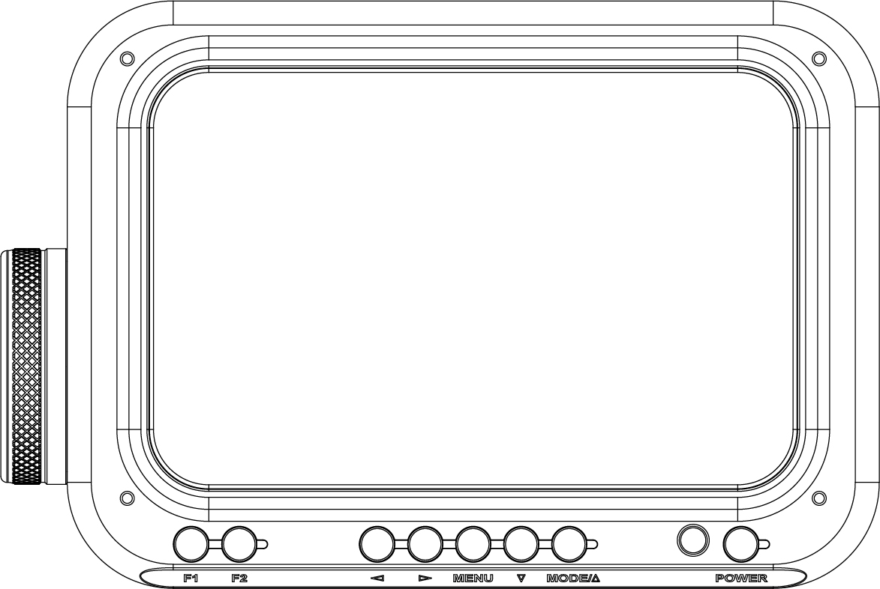
User Manual

Product Overview
Thank you for purchasing the Kraken Ultra Bright 7" 4K Underwater Monitor. This monitor is a professional grade IPS LED panel, boasting extremely high brightness, low power consumption, and stable performance. Equipped with HDMI input and output and optional SDI, the monitor is ideal as a portable, lightweight viewfinder and video monitor, but suitable for a variety of different applications.
Advanced features include:

- Histogram
- False colours
- Zebra exposure
- Focus assist
- Nine grid
- Embedded audio
- Center marker
- Safe frames
- Colour temperature
- Picture settings
- Colour settings

CAUTION
To ensure proper function of the monitor, please read the user’s manual carefully.
- Discontinue use immediately should you notice any water leaking from the monitor.
- Discontinue use immediately should you notice any cracks on the LCD screen.
- Do not open the battery cap or the bulkhead cap in a wet or sandy environment.
- Avoid dropping the monitor.
- The LCD screen of this product is made of glass. Protect the screen from falls, or coming into contact with hard objects.
- Keep the monitor away from heat sources, such as radiator, water heaters, stoves, etc.
- Avoid prolonged exposures to the sun, as the LCD screen could be damaged.
- The charger included is a USB C PD, standard USB C chargers will not charge the battery. It is recommended to use only the battery and charger included.
- Always turn off the monitor before removing the battery.
- To avoid damaging the product, please do not take apart or repair the unit by yourself.
- For optimal maintenance, and to avoid scratching the screen, gently wipe the screen using a clean, soft fibred cloth. Do not use chemical solutions to clean the screen.
General Features
- Waterproof 80m/266ft
- 2200nit Brightness
- IPS 4K LCD panel (SDI 1080p only)
- 4K HDMI signal input/output
- 3840×2160p (30/29.97/25/24/23.98 Hz) / 4096×2160p (24Hz)
- ~3 hours runtime at max brightness
- Analog stereo L/R, embedded audio display
- Histogram
- Focus assist - focus edge can be red, green, or blue
- Zebra exposure and false colour function
- Check field - red, green, blue, mono
- Anamorphic mode

Image Features
- Flip (H, V, H/V)
- Image Freeze
- Nine grid - zoom one of the images to full screen
- Image Zoom-in function
- Pixel to pixel
- Marker types, safe frames and center marker
- Display and adjust the image colour temperature
- Brightness, contrast, tint, saturation and colour temperature adjustment

Package Contents

1. Monitor (Including HDMI-IN and HDMI-OUT bulkheads)
2. Battery
3. USB-C PD charger (AC adapter)
4. USB-C PD cable (for charging the battery)
Note: always must use a USB C PD cable, standard USB C will not charge the device
5. HDMI cable (60cm)
6. HDMI bulkhead with M16 thread with soft cable
7. M16-M24 thread adapter for HDMI bulkhead
8. Micro HDMI plug
9. Mini HDMI plug
10. Standard HDMI plug
11. Ball mount
12. Spare O-ring for battery cap (O ring ID49 x CS2.0)
13. Spare O-ring for bulkhead (O ring ID26 x CS1.5)
14. Spare O-ring for M16-M24 thread adapter (O ring ID20 x CS2.0)

Product Description
- Front Panel/ Button Instruction

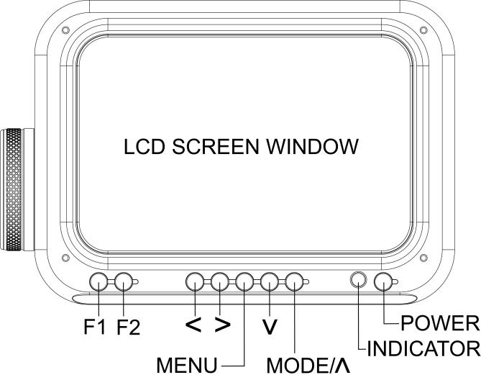

Button | Function when OSD is not displayed | Function when OSD is  displayed
F1 | Custom button F1 | N/A
F2 | Custom button F2 | N/A
＜ | press < button for volume shortcut, then press < and > button to adjust the volume | Decrease or adjust value of selected parameter
＞ | press > button for backlight shortcut, then press < and > button to adjust backlight brightness | Increase or adjust value of selected parameter
MENU | Display OSD main menu | Return to previous OSD m
∨ | N/A | Select next menu item
MODE/∧ (SDI Version) | Signal input selection | Select previous menu item
∧  (W/O SDI Version) | N/A | Select previous menu item
POWER | Power on/off button

- Rear Panel Instruction

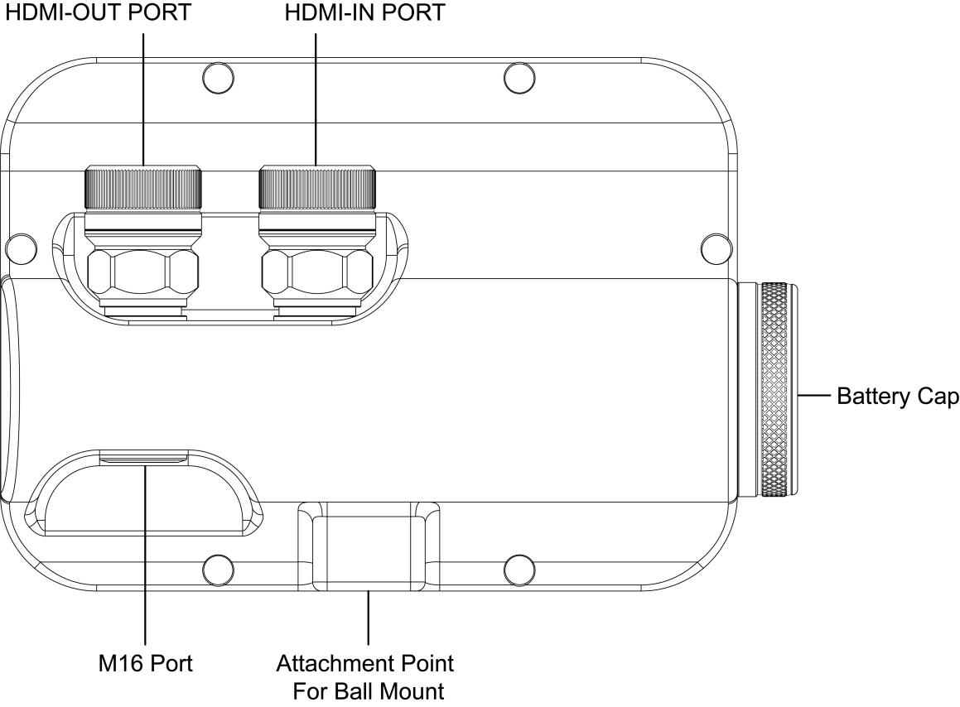

- Battery / Charger
1. Only use Li-ion battery provided by the manufacturer.
2. Do not open the battery cap when the monitor is in the water.
3. If the monitor will not be used for a long period of time, the battery should be removed.
4. To charge the battery, use the USB-C PD charger included with your monitor.
5. When the battery begins to charge, the indicator light on the battery will be RED.
6. When the battery is fully charged, the indicator light on the battery will change to BLUE.

Operating Your Monitor

- After correctly installing the battery, press and hold the "POWER" button for one second. The indicator ring will be blue or red and the monitor will turn on.
- When the menu is not displayed, pressing the < button will allow adjustment of the volume, or pressing the > button will allow adjustment of the backlight.
- Press the MENU button to access the main menu. Use the < or > buttons to scroll through the menu categories across the top. Once you have selected the desired menu category, use the ∨ or MODE/∧ buttons to scroll through the list of items within that category. Press the MENU button again to return to the menu categories across the top, or a second time to exit the menu.

Menu Categories and Options

Shooting Assistant
Menu Items | Options
Histogram | Off, On
Focus Assist | Off, On
Peaking Colour | Red, Green, Blue
Embedded Audio | Off, On
Over Exposure | Off, On
Exposure Level | IRE10~IRE100
Check Field | Off, Mono, Red, Green, Blue
False Colours | Off, On

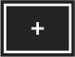

Sight Marker
Menu Items | Options
Nine Grid | Off, On
Safe Frames | Off, 80%, 85%, 90%, 93%, 96%, 2.35:1
Center Marker | Off, On
Ratio Marker | Off, 4:3, 13:9, 14:9, 15:9, 16:9, 1.85:1, 2.35:1
Mark Colour | Red, Green, Blue, Black, White
Mark Width | 1~7
Modified Mark | 0~5

Zooming
Menu Items | Options
Scan Mode | Under Scan, Over Scan
Aspect Ratio | Auto., 4:3, 16:9, Ful Screen, Panorama, P2P
Anamorphic | Off, 1.3X, 2.0X, 2.0X MAG, User
Anamorphic nX | 1.20X~2.00X
Image Flip | Off, H Flip, V Flip, H_V Flip
OSD Flip | Off, On
Zoom Mode | Off, Mode1, Mode2  The Zoom All, L/R Zoom, U/D Zoom can be customized
Zoom All | 0~500
L/R Zoom | 0~500
U/D Zoom | 0~500
Nine Grid Zoom | Off, On  Open the Nine Grid function in the *** menu category to divide the image into the nine grid. Use the < or > buttons to scroll to the desired part of the screen, press the ∨ button to zoom to full screen. Pressing the ∨ button again will zoom out to the previous screen.
Zoom | Off, 4X, 9X, 16X
Image Freeze | Off, On
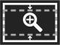

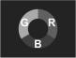

Image Colour
Menu Items | Options
Lut Switch | Off, On  When turned on, you can use the Lut (SLOG2, SLOG3, LOGC, VLOG).
Lut Table | Shows the 4 built-in Lut and the custom load Lut
Lut Import (USB) | After copying the 3D Lut file to a USB flash drive, and connecting USB UPGRADE port via USB adapter cable, press the < or > button in the Lut Import(USB) to import the 3D Lut file.
Colour Temperature | 5600, 6500, 9300, User  Under “User”, the red, green and blue of the image can be adjusted.
Red | 0~255
Green | 0~255
Blue | 0~255
Backlight | 0~100
Pic. Mode | Standard, Mild, User, Dynamic  Under “User”, you can adjust the image brightness, contrast, saturation and sharpness.
Brightness | 0~100
Contrast | 10~100
Saturation | 0~100
Sharpness | 0~100
Tint | 0~100

Setting
Menu Items | Options
Left Right Key Set | Volume, Backlight  You can set the “Left Right Key Set” as shortcut keys for backlight adjustment. After setting, when the menu is not displayed, you can directly press the < or > key for quick adjustment.(This device does not have the speaker.)
Languages | English, 简体中文, Español, Português, Français, Nederlands, Deutsch, 日本語, 繁體中文, 한국以로, руссKий языK
OSD Trans. | Off, Low, Middle, High
OSD Time | Off, 10 seconds, 20 seconds, 30 seconds
No Signal | Blue Screen, Red Screen, Green Screen,  Gray Screen, Black Screen, White Screen
Volume | 0~100
USB Upgrade | Copy the file to the USB flash drive, then connecting USB UPGRADE port via USB adapter cable, press the ">" button to confirm the upgrade. After the upgrade is complete, the monitor will automatically restart.
Reset | Pressing the ＞ button will reset the monitor back to factory settings.

The two shortcut buttons F1 and F2 can be programmed with a feature of your preference. To set each button, select the menu category, then press the ∨ button to select F1 or F2. Use the < and > buttons to scroll through the feature options, and press the MENU button to confirm your selection and program the shortcut button.

Options: safe frames, check field, focus assist, aspect ratio, image flip, image freeze, histogram, false colours, over exposure, embedded audio, nine grid, zoom, anamorphic, center marker

Technical Parameters

Panel Size | 7" IPS
Resolution | 1920x1200 pixels
Dot Pitch | 0.07875(W) x 0.07875 (H)mm
Aspect Ratio | 16:10
Brightness | 2200cd/m2
Contrast | 1200: 1
Viewing Angle | 80°/80°(L/R) 80°/80°(U/D)
Backlight | LED
Input | SDI (Optional), HDMI
Output | SDI (Optional), HDMI
SDI Support Format | 480i/576i  720p (60/59.94/50/30/29/25/24/23.98)  1080i (60/59.94/50)  1080p(60/59.94/50/30/29.97/25/24/24sF/23.98/23.98sF)
HDMI Input / Output Support Format | 480i/576i/480p/576p  720p(60/59.94/50/30/29/25/24/23.98)  1080i(60/59.94/50)  1080p(60/59.94/50/30/29.97/25/24/24sF/23.98/23.98sF)  4K UHD 3840×2160p (30/29.97/25/24/23.98 Hz) 4096×2160p (24Hz)
Power Consumption | ≦18W
Unit Size | 220Lx147Hx90D (mm)
Unit Weight | 2214g on land/560g underwater (With battery)
Mount Points | 1/4"-20 Thread Point (For mounting ball )
Working Temperature | -20℃~55℃
Storage Temperature | -30℃~65℃
Depth Rating | 80 meters/266ft

Installing the battery

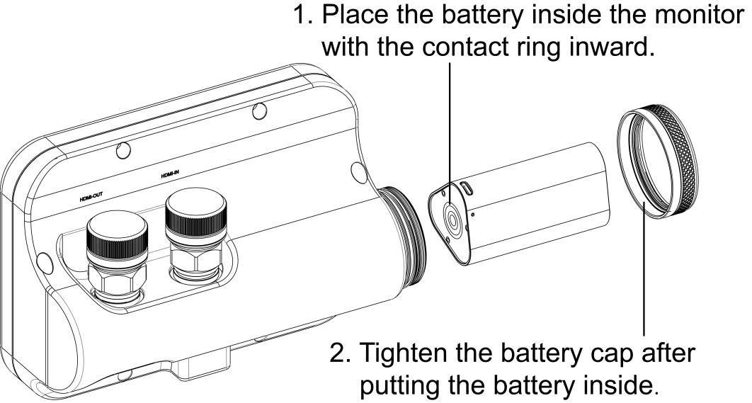

Connecting the HDMI cable to the monitor

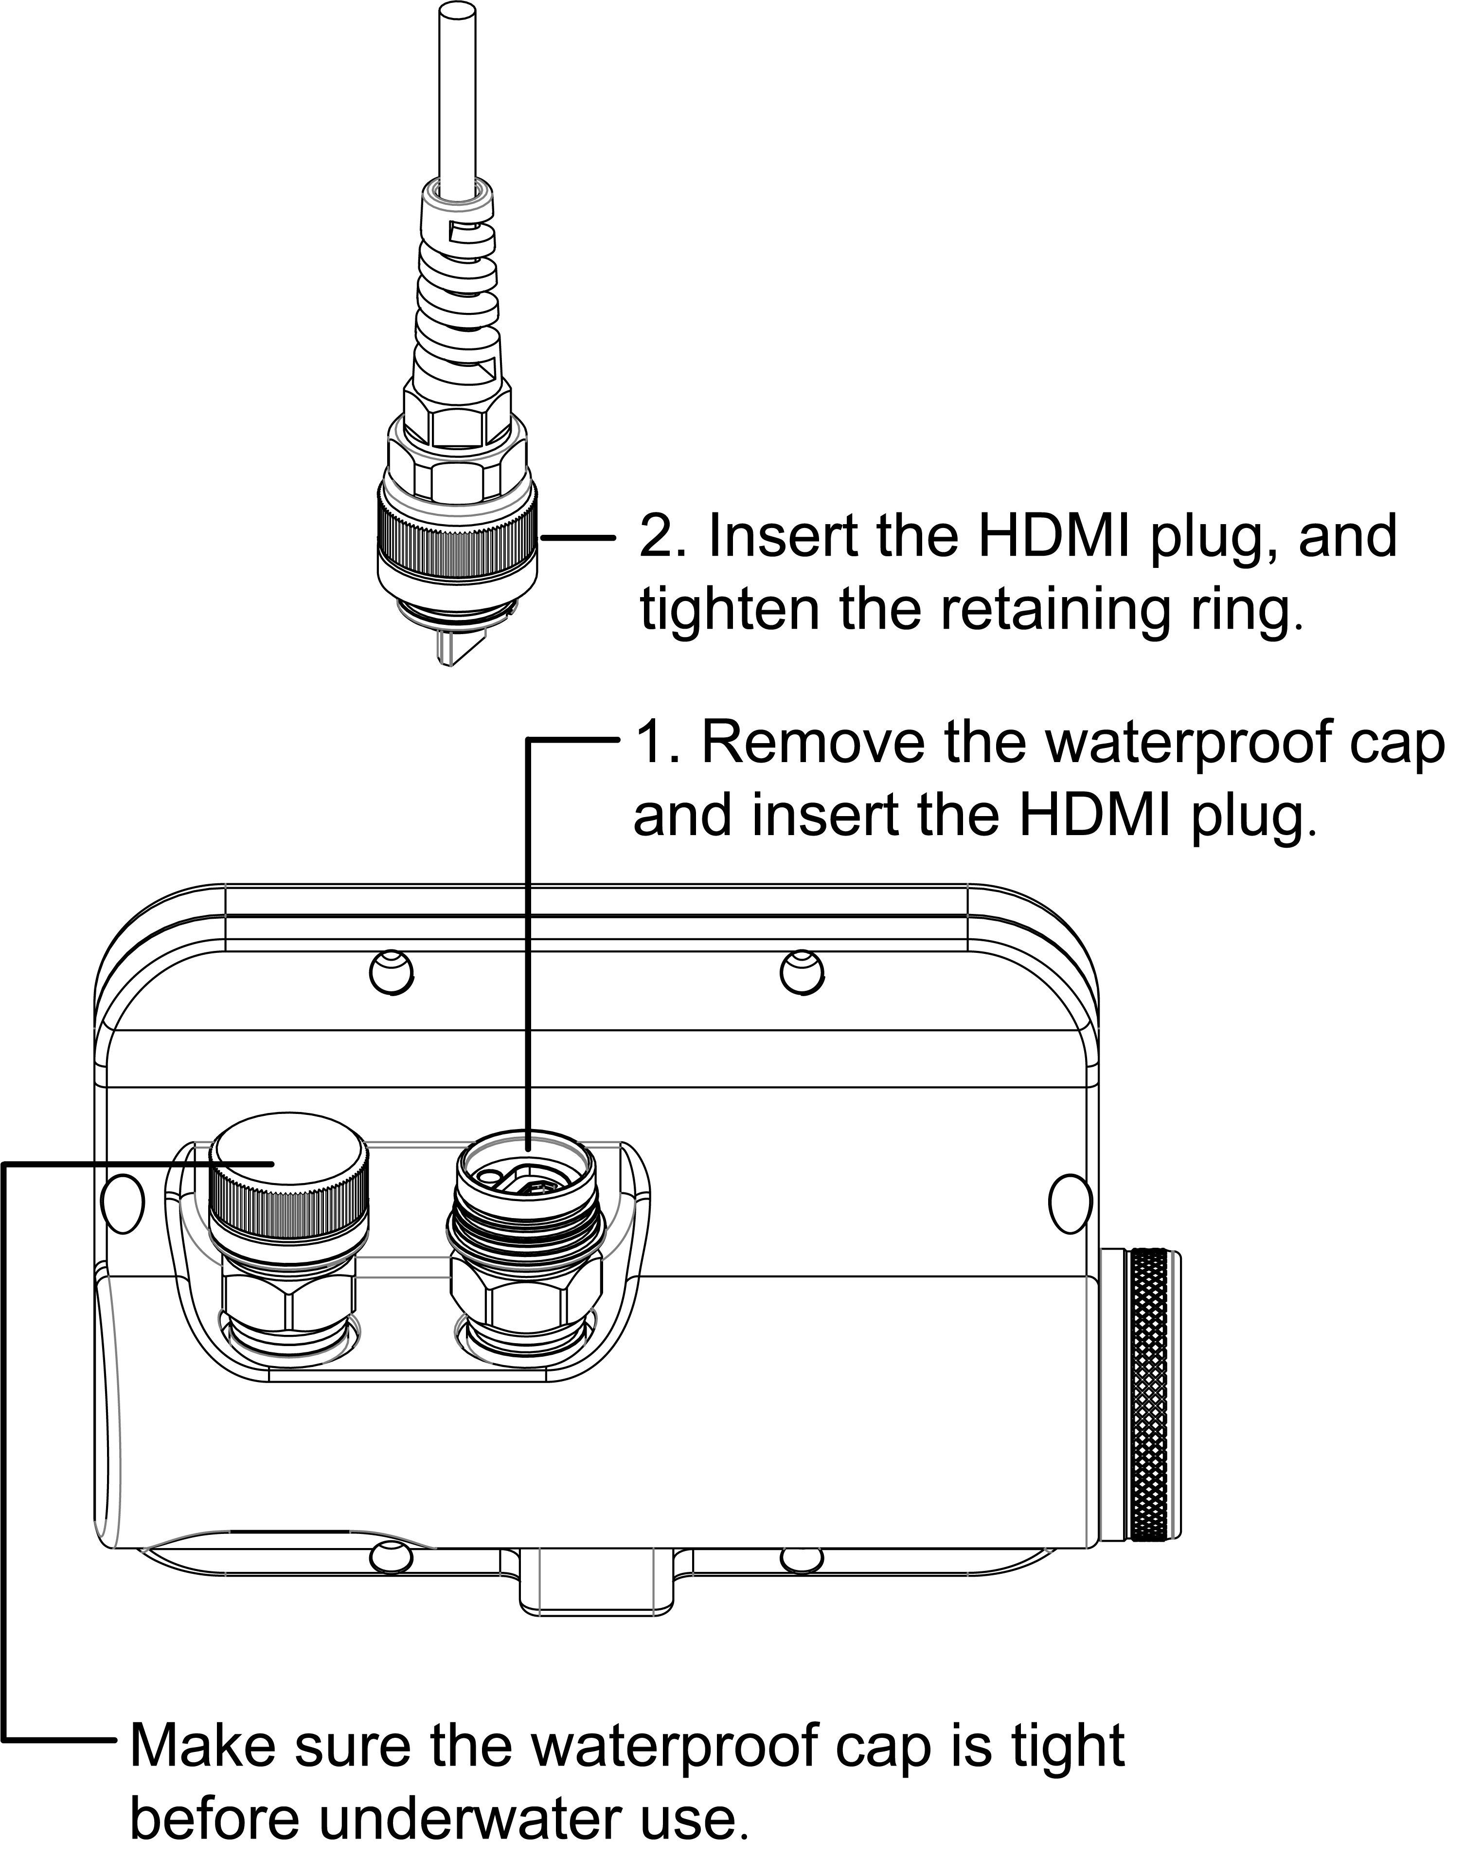

Connect to camera housing

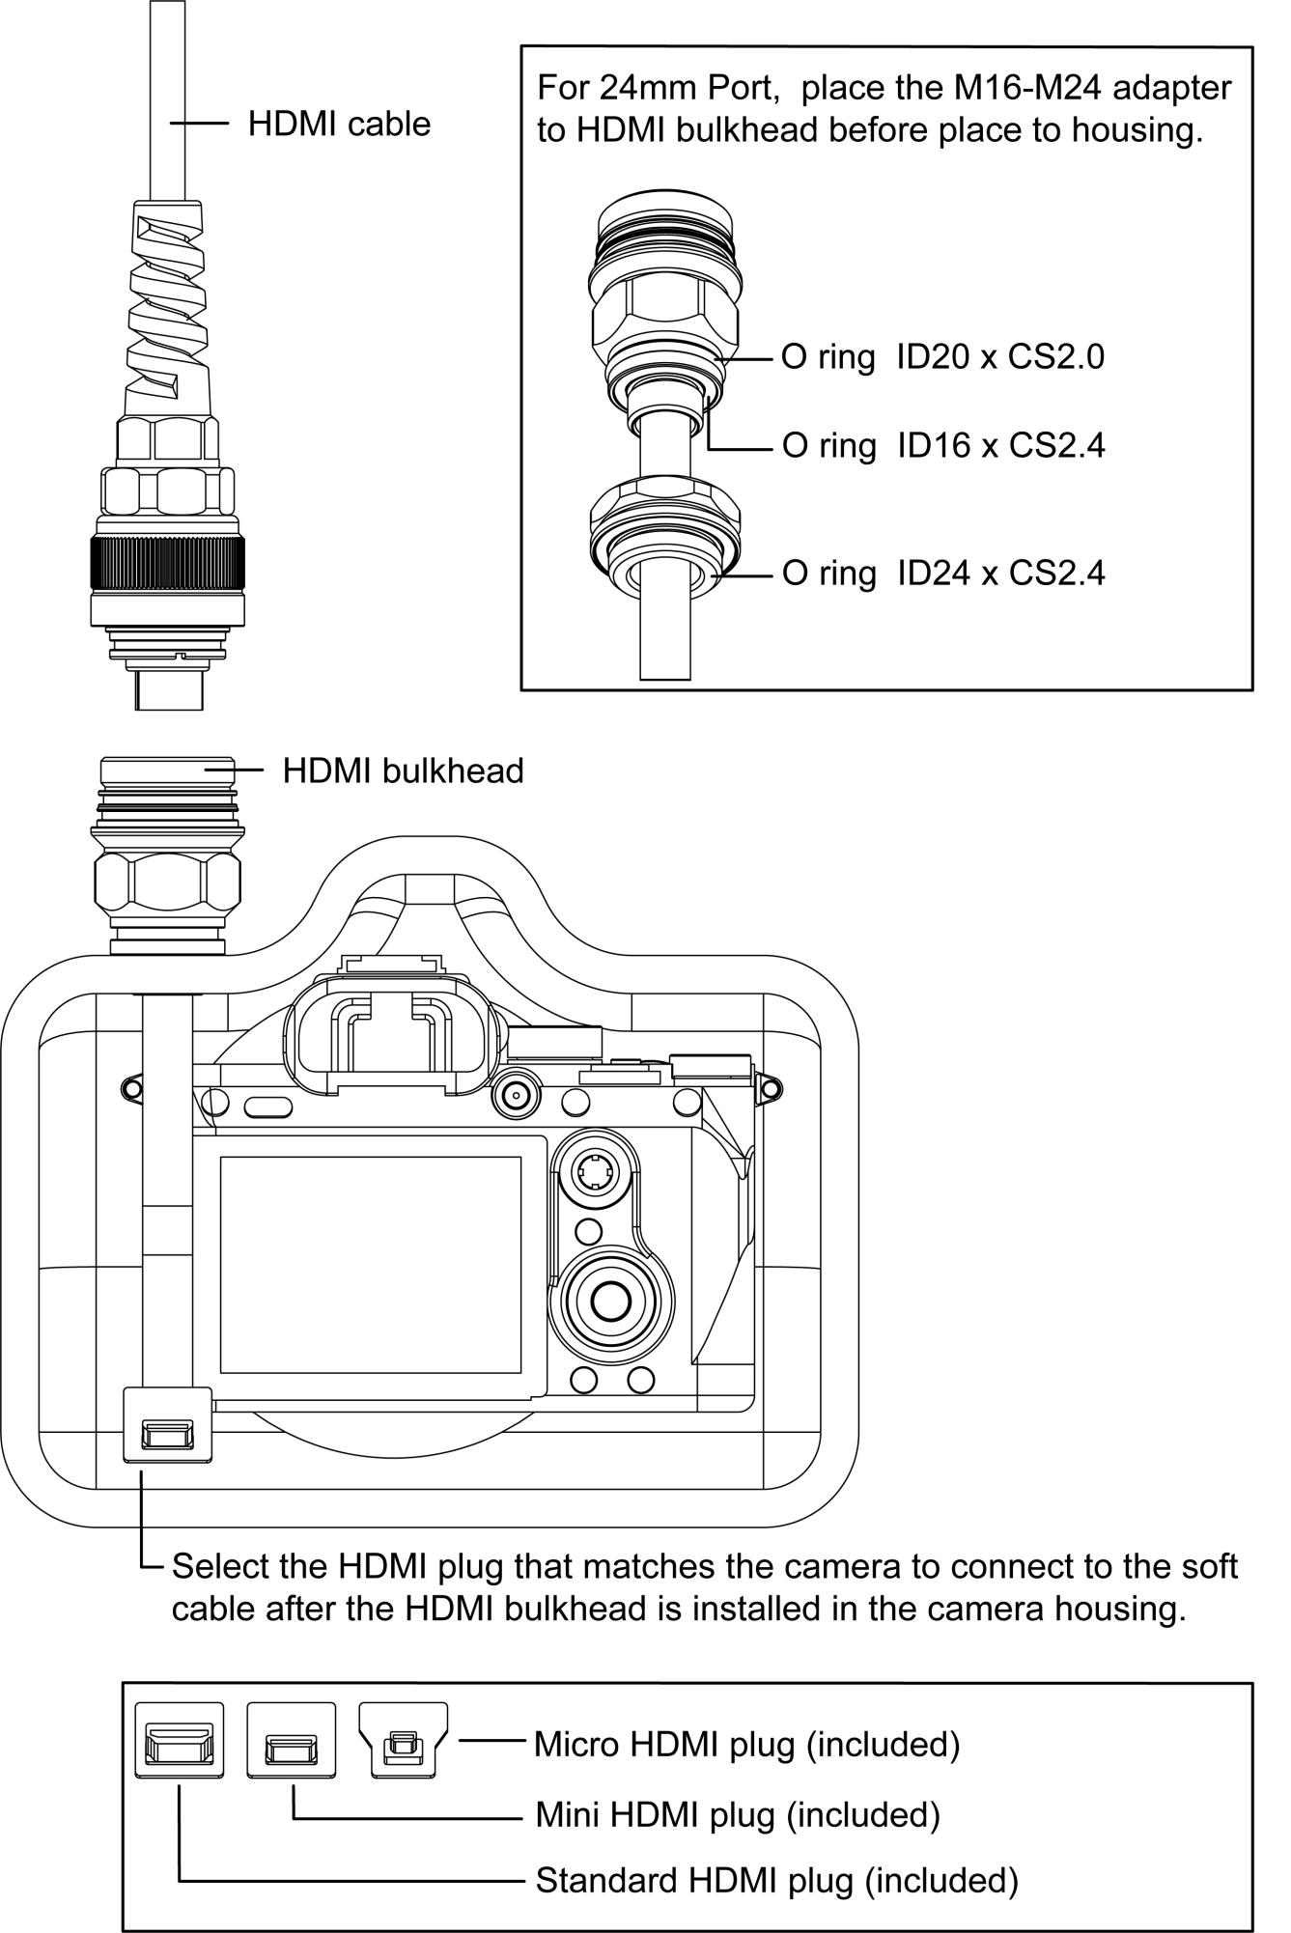

Troubleshooting

Monitor showing only black and white, or monochrome picture.
- Check saturation, brightness & contrast adjustment.
- Check if Check Field in the menu is in black, white or monochrome image or other condition.
There is no image after powering the monitor on.
- Check HDMI\SDI cable, cable connections, and if monitor is synchronized with the input signal.
- Check signal cable connection, and make sure to use the standard adapter to connect the monitor. If power is supplied by battery, please check if the battery is fully charged.

As we are constantly striving to improve performance, these specifications are subject to change.

